**Staffing Management Plan**

**Date**

**Project Name**: UOW Booking System Development

**Staffing Requirements**

This project will require the following internal staff:

This Project will require 6 staff, Project Manager, Lead Developer, Administrator, Finance Director, Operation Manager, Project Coordinator.

**Staff Assignments**

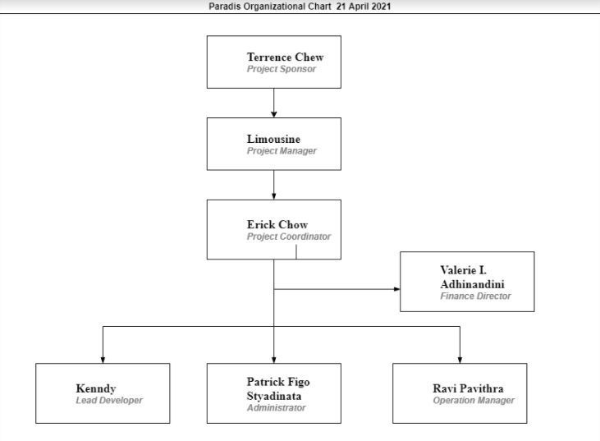

|  |  |  |
| --- | --- | --- |
| **Limousine** | **Lead and Monitor the Project** | **Project manager** |
|  |  |  |
| **Kenndy** | **Sets for the standard for the program as well as the technical direction.** | **Lead Developer** |
| **Patrick Figo Styadinata** | **Ensure that all work and customer handling is done professionally.** | **Administrator** |
| **Valerie I. Adhinandini** | **Oversee, review, and adhere to the budgets for each business department.** | **Finance Director** |
| **Ravi Pavithra** | **Manage operation process, enfold designs, performance improvements and strategize operations.** | **Operation manager** |
| **Erick Chow** | **Ensure the project is running on time and within budget.** | **Project Coordinator** |

**Training, Rewards, and Reassignment**